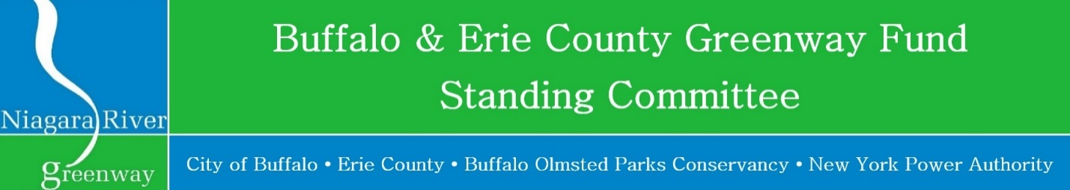

# **Grant Schedule**

# **2024:**

# Tuesday, January 23, 2024                     **Deadline for submission of applications (4 PM EST)**

Applications (2- hard copies: single sided & 1-thumb drive, Microsoft Word) should be submitted to:   
Carol Jasen Sampson  
New York Power Authority   
Electric Tower Building   
535 Washington Street, Suite 202   
Buffalo, NY 14203  
(716) 842-3232  
[Carol.Sampson@nypa.gov](mailto:Carol.Sampson@nypa.gov)

Wednesday, February 21, 2024                **Public Meeting: Public presentations of submitted projects**  
  
LOCATION: Community Foundation for Greater Buffalo  
726 Exchange Street, Suite 525, Buffalo, NY 14210

TIME: 4:00 PM

Friday, March 15, 2024                               **Public Meeting: Announcements of Awards**  
  
LOCATION: Community Foundation for Greater Buffalo  
726 Exchange Street, Suite 525, Buffalo, NY 14210

TIME: 8:30 AM