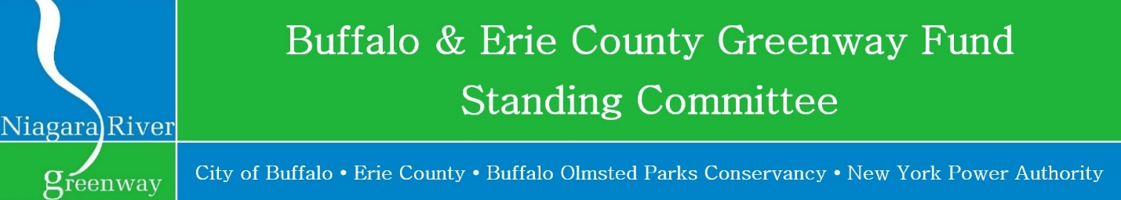
Revised 11/21/2022

2023 Grant Schedule

Tuesday, January 24, 2023 Deadline for submission of applications (4 PM EST)
Applications (2- hard copies: single sided & 1-thumb drive, Microsoft Word) should be submitted to:
Carol Jasen Sampson
New York Power Authority
Electric Tower Building
535 Washington Street, Suite 202
Buffalo, NY 14203
(716) 842-3232
Carol.Sampson@nypa.gov
Wednesday, February 22, 2023 Public Meeting: Public presentations of submitted projects
LOCATION: Community Foundation for Greater Buffalo
726 Exchange Street, Suite 525, Buffalo, NY 14210
TIME: 4:00 PM
Friday, March 17, 2023 Public Meeting: Announcements of Awards
LOCATION: : Community Foundation for Greater Buffalo
726 Exchange Street, Suite 525, Buffalo, NY 14210
TIME: 8:30 AM

